25-05-2020
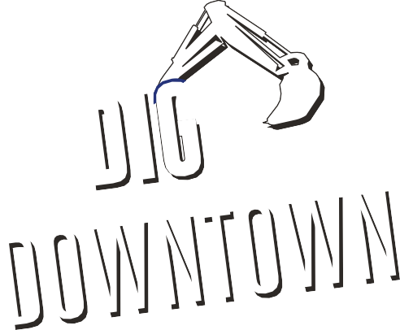  1 | Health & Safety  All ACL employees, subs/suppliers to follow Covid 19 handbook.  Proper protective equipment shall be worn at all times, inside the work area.  Pedestrian Traffic and Deliveries will be directed by the Safety Ambassadors on site.  All vehicular traffic is now being detoured around the work area.  Access through the work area will only be for emergency vehicles and local residence as well as prearranged deliveries with the Public Relations Officer.
2 | Work Completed Today  Side walk preparation at #80 Dunlop Street East (Homestead), moving westbound to #70 (Hooligans)  Continuation of storm structure installation Phase 3  Guild on site installing hydro poles bases
3 | Work Scheduled for Tomorrow  Soil Cell installation continues at #15-9 Dunlop Street East, Southside.  Side walk preparation at #70 Dunlop St east (Hooligans) moving westbound on North side. (Dollarama)  Continuation of storm structure installation Phase 3  Guild to continue installation of poles bases
4 | Business Impact  All stores will be accessible via pedestrian walkways with planned interruptions in the walkway area May 25th to May 26th.  Deliveries for all businesses located between Maple Ave. and Mary St., as well as Clapperton Street to Mulcaster Street are to be coordinated with the Project Public Relations Officer -Nicole Maurice (705) 794-7800
5 | Business Impact: Garbage  All Garbage and Recycling is to be placed in the normal location (behind the hoarding fence) at the same time as per the City of Barrie regulations. Arnott Construction Ltd will ensure all Garbage and Recycling is collected as long as it meets the City of Barrie Waste Collection criteria. Garbage collection to begin at 7am.
6 | Emergency Service  Please be advised that there is no through traffic East and West bound on Dunlop Street between Maple Ave. and Mary Street as well as Clapperton St. to Mulcaster St. Hoarding fencing has been placed east and west of the Owen St. and Dunlop St. intersection to stop pedestrian and vehicle traffic within the job site. Fencing will need to be physically removed for access to job site.

Dunlop Street Corridor Improvements Contract 2019-083T

