19-05-2020
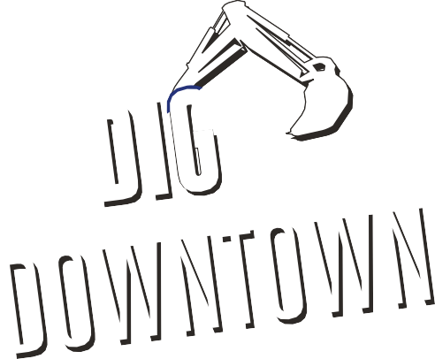  1 | Health & Safety  All ACL employees, subs/suppliers to follow Covid 19 handbook.  Proper protective equipment shall be worn at all times, inside the work area.  Pedestrian Traffic and Deliveries will be directed by the Safety Ambassadors on site.  All vehicular traffic is now being detoured around the work area.  Access through the work area will only be for emergency vehicles and local residence as well as prearranged deliveries with the Public Relations Officer.
2 | Work Completed Today  Soil Cell repair at #20 Dunlop Street East, Northside of Dunlop Street.  Guild continues to install electrical conduits at #55 Dunlop Street East, moving west.  Road Preparation for remainder of Phase 1A and some of Phase 1B  Watermain tie ins Intersection of Maple Ave and Dunlop St (Extended hours with water disruption)  Spring Tree Farms installing trees in Phase1A
3 | Work Scheduled for Tomorrow  Soil Cell repair at #41 Dunlop Street East, Southside of Dunlop Street.  Soil Cell installation continues at #29 Dunlop Street East, Southside of Dunlop, West of Meridian Place (British Arms).  Guild continues to install hydro ducts at #41 Dunlop Street East, moving West.  Curb installation in remainder of Phase 1A and some of Phase 1B  Continuation of watermain tie in Phase 3 (No water disruptions planned)  Plantings installing Phase 1A.
4 | Business Impact  All stores will be accessible via pedestrian walkways with planned interruptions in the walkway area May 19th to May 20th.  Deliveries for all businesses located between Maple Ave. and Mary St., as well as Clapperton Street to Mulcaster Street are to be coordinated with the Project Public Relations Officer -Nicole Maurice (705) 794-7800
5 | Business Impact: Garbage  All Garbage and Recycling is to be placed in the normal location (behind the hoarding fence) at the same time as per the City of Barrie regulations. Arnott Construction Ltd will ensure all Garbage and Recycling is collected as long as it meets the City of Barrie Waste Collection criteria. Garbage collection to begin at 7am.
6 | Emergency Service  Please be advised that there is no through traffic East and West bound on Dunlop Street between Maple Ave. and Mary Street as well as Clapperton St. to Mulcaster St. Hoarding fencing has been placed east and west of the Owen St. and Dunlop St. intersection to stop pedestrian and vehicle traffic within the job site. Fencing will need to be physically removed for access to job site.

Dunlop Street Corridor Improvements Contract 2019-083T

