09-04-2020
1 | Health & Safety  Proper protective equipment shall be worn at all times, inside the work area.  Pedestrian Traffic and Deliveries will be directed by the Safety Ambassadors on site.  All vehicular traffic is now being detoured around the work area.  Access through the work area will only be for emergency vehicles and local residence as well as prearranged deliveries with the Public Relations Officer.
2 | Work Completed Today  Water Services for 34 Dunlop Street East  Continuation of Catch Basins on South side of Dunlop Street for Soil Cells.
3 | Work Scheduled for Next Week  Continuation of Catch Basin installation on South side of Dunlop Street  Water Service Connections  Unit Paver stones repairs in Phase 1A  Soil Cell Installation
4 | Business Impact  All stores will be accessible via pedestrian walkways with no planned interruptions in the walkway area from April 9th to April 13th, 2020.  Deliveries for all businesses located between Clapperton Street and Mulcaster Street to be coordinated with the Project Public Relations Officer -Nicole Maurice (705) 794-7800
5 | Business Impact  All Garbage and Recycling is to be placed in the normal location (behind the hoarding fence) at the same time as per the City of Barrie regulations. Arnott Construction Ltd will ensure all Garbage and Recycling is collected as long as it meets the City of Barrie Waste Collection criteria. Waste Collection to occur on Saturday morning.
6 | Emergency Service  Please be advised that there is no through traffic East and West bound on Dunlop Street between Clapperton Street and Mulcaster Street. Hoarding fencing has been placed east and west of the Owen and Dunlop Street intersection to stop pedestrian and vehicle traffic within the job site. Fencing will need to be removed for access to job site.

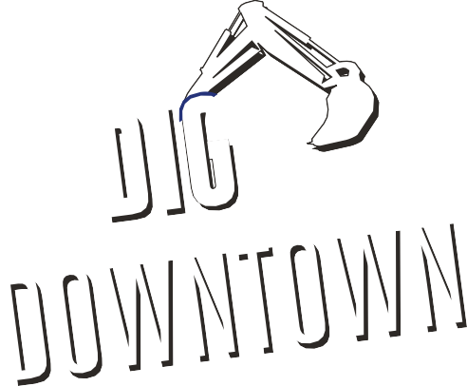
Dunlop Street Corridor Improvements Contract 2019-083T
DATE

